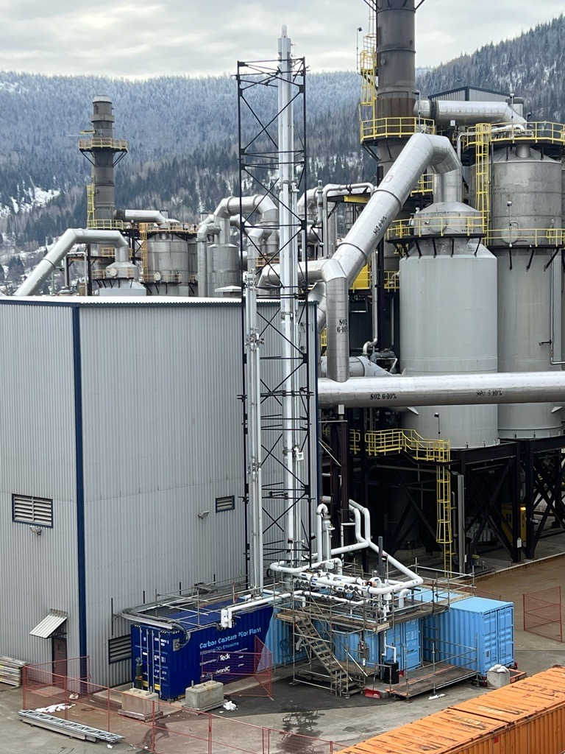
0
Shell Cansolv - Technip amine capture technology
Rapid, affordable entry into carbon capture piloting

Carbon Capture

Pilot Plant

Amine Capture Process
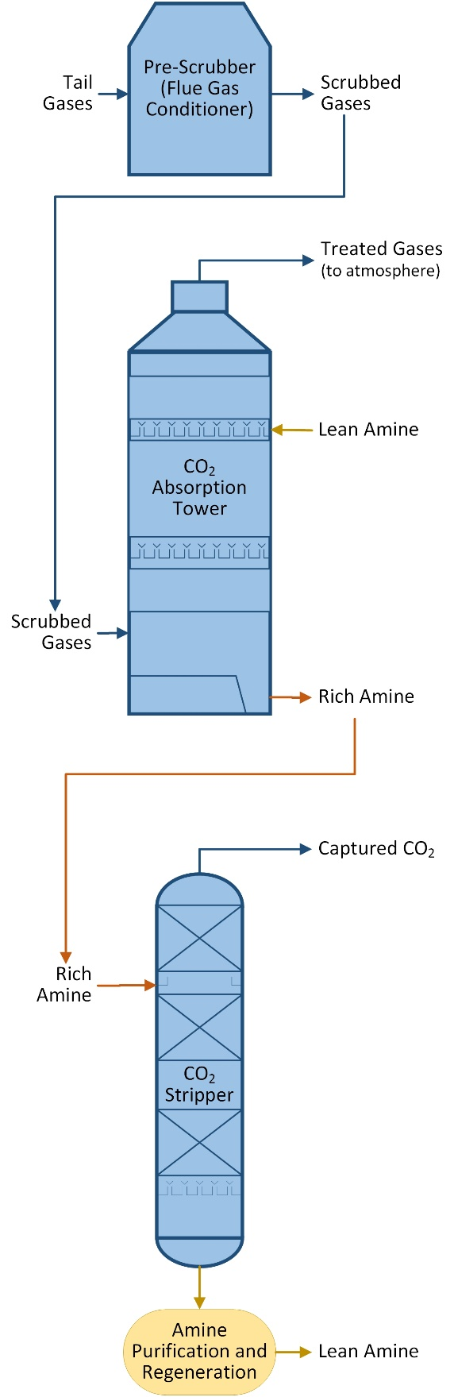
The process is a thermal shift process, i.e., using a solvent that absorbs CO₂ when cool and releases it when hot. The Pilot Plant is designed by Technip specifically for the Shell DC-103 amine solvent.
The rich amine solvent flows to a CO₂ stripping column, where it is heated to 100°C to release ethe CO₂. The CO₂ can then be sent to downstream processes for cooling, compression, and storage.
The gas stream is passed into a cross-flow of “lean” amine solvent introduced at the top of the absorption column. The solvent absorbs the carbon dioxide as it flows to the bottom of the column, becoming “rich”, or saturated with CO₂.
A pre-scrubber reduces the temperature of the tail gases, knocks out any contained SO₂, and fully saturates the gas stream with water.
The stripped amine solvent is cooled to 25°C and returned to the absorption column to repeat the process.

Offered for Sale
Equipment and optional instrumentation for a self-contained, ready-to-install carbon capture plant and office building.

Included Equipment
- Pre-scrubber / cooler
- Absorber
- Stripper
- Reflux drum
- Lean amine pump
- Rich amine pump
- Wash water pump
- Reflux pump
- Booster fan
- Absorber intercooler
- Rich / lean exchanger
- Waste water cooler
- Lean amine cooler
- Reboiler
- Reflux condenser
- Activated carbon filter
- Brownian diffuser unit
- Lean amine tank
- Electrical distribution and switching
- Control instruments and computer

Optional Instrumentation
- ELPI+
- FTIR

Compatible Applications
- Coal combustion
- Gas combustion - fired boilers
- Gas combustion - CCGT
- SMR furnace off-gas
- FCC regenerator off-gas
- Cement kiln off-gas
- Steel production (blast furnace, DRI)
- Other metallurgical production off-gas
- Acid plant tail gas

Specifications

Capture Rate
1 – 5 tonnes per day CO₂ removal, depending on inlet gas conditions.

Process Outputs
- Decarbonized gas
- Pure CO₂ (wet, atmospheric pressure)

Shipping Size
- 2x 40’ sea-cans
- 1x 20’ sea-can
- 1x 10’ sea-can

Utility Requirements
Utility | Estimated Requirement
Cooling water | 75-100 m³/t CO₂ capture
Make-up water | 0.25 m³/t CO₂ capture (process water for direct contact cooler)
Electricity | 600V/400A service required
LP steam | None required for pilot - electric reboiler is used
High-level steam | None required for pilot
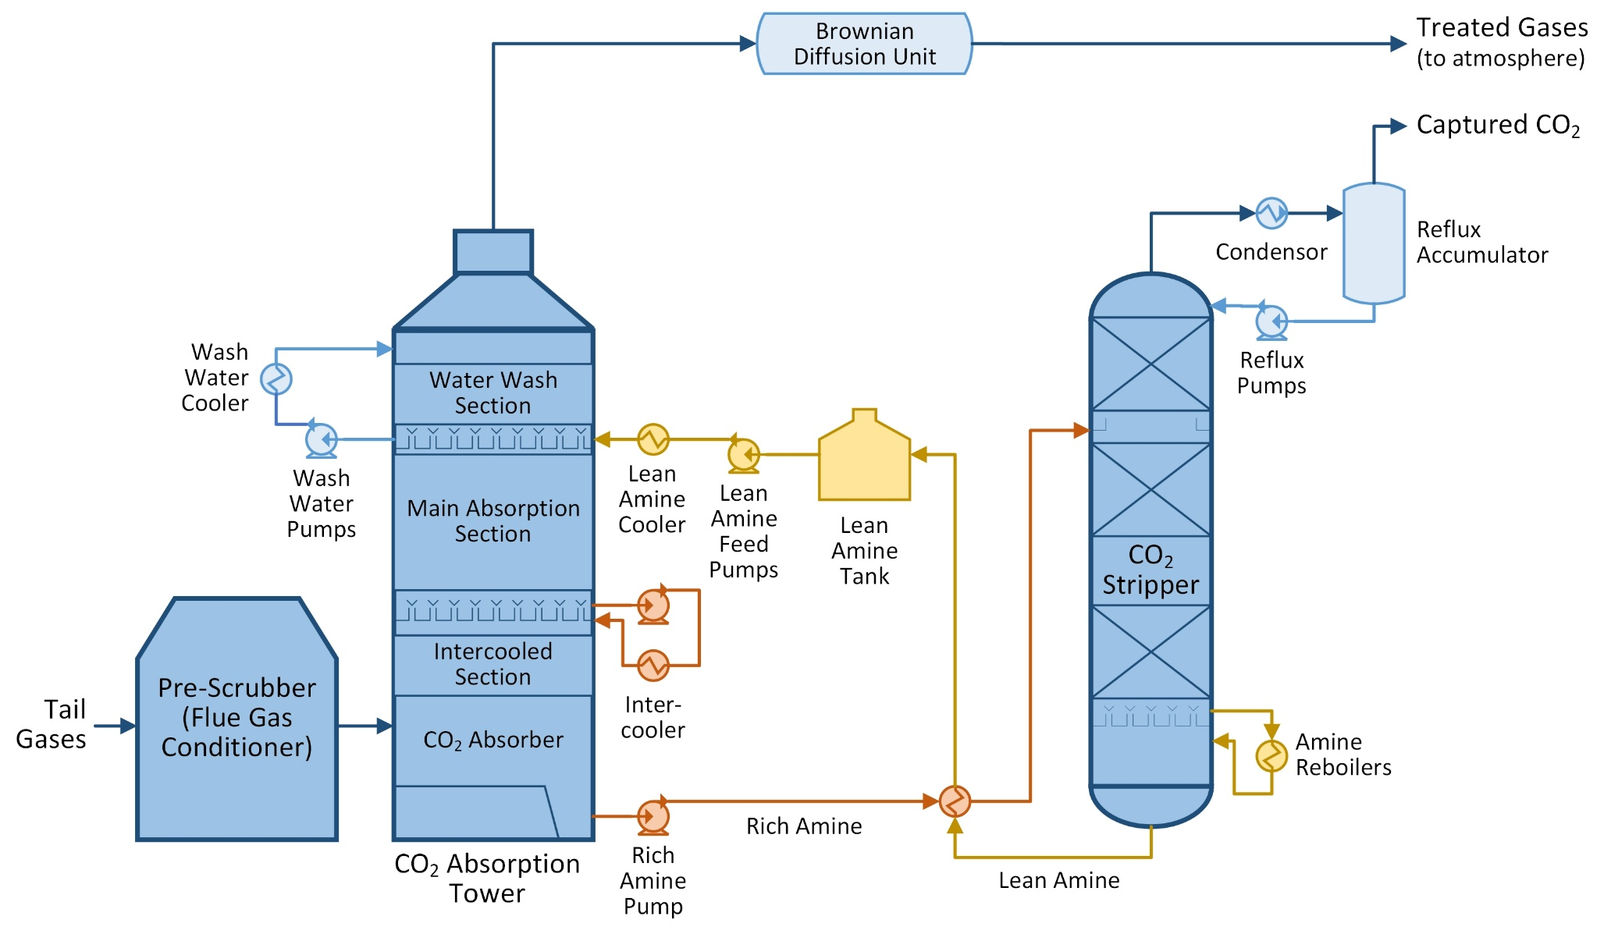

Shell Cansolv Carbon Capture Plant

